**LAB REPORT #6** Name: Owais Rao

Roll No.:22L-7638

Class: BSEE-1A2

**Introduction:-**

Switch case statement evaluates a given expression and based on the evaluated value (matching a certain condition), it executes the statements associated with it. Basically, it is used to perform different actions based on different conditions (cases).

**Objective:-**

* To be able to understand switch structures.
* To be able to use switch structure for evaluating problems.
* To be able to understand the logic of loops.

**Procedure:-**

With the help of lab manual, I was able to write codes for given exercises. They are as follows with their outputs:-

**Exercise 1:-**

#include <iostream>

using namespace std;

void main()

{

char operation;

int num1 = 0, num2 = 0, result = 0, remain = 0;

cout << "Enter numbers: " << endl;

cin >> num1 >> num2;

cout << "What operation would you like to perform:" << endl

<< " + addition\n - subtraction\n * multiplication\n / division\n % modulus\n" << endl << endl << "Operation? ";

cin >> operation;

switch (operation)

{

case '+':

result = num1 + num2;

cout << "\nResult: " << result << endl;

break;

case '-':

result = num1 - num2;

cout << "\nResult: " << result << endl;

break;

case '*':

result = num1 * num2;

cout << "\nResult: " << result << endl;

break;

case '/':

result = num1 / num2;

cout << "\nResult: " << result << endl;

break;

case '%':

result = num1 % num2;

cout << "\nResult: " << result << endl;

break;

default:

cout << "\nInvalid operator!" << endl;

break;

}

}

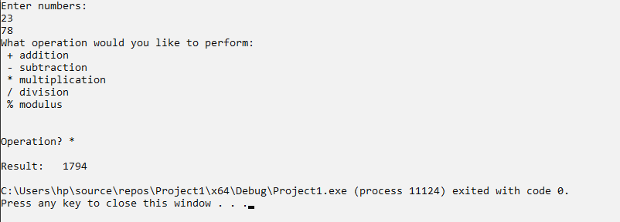

**Exercise 2:-**

#include <iostream>

using namespace std;

void main()

{

int N;

double factorial = 1;

cout << endl << "Enter variable: ";

cin >> N;

while (N > 1)

{

factorial = factorial * N;

N--;

}

cout << endl << "Factorial= " << factorial << endl;

}

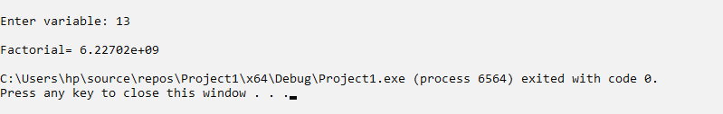

**Exercise 3:-**

#include <iostream>

using namespace std;

void main()

{

int N, x = 1, y;

cout << "\n Enter variable for table: ";

cin >> N;

while (x <= 20)

{

y = N * x;

cout << " " << N << "*" << x << "=" << y << endl;

x++;

}

}

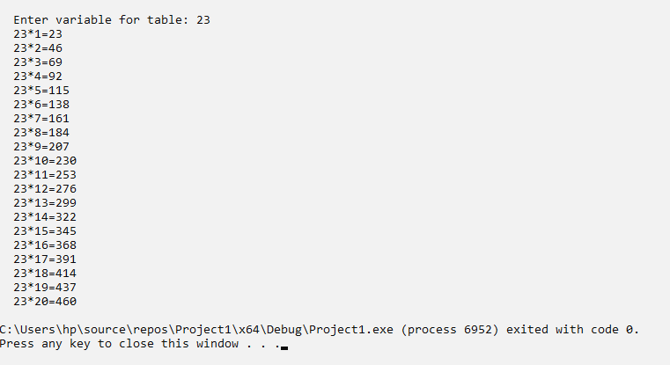

**Issues:-**

No issues were faced.

**Conclusion:-**

* I was able to understand switch structures.
* I was able to use switch structure for evaluating problems.
* I was able to understand the logic of loops.

**Applications:-**

* They are a substitute for long if statements that compare a variable to several integral values.
* The switch statement is a multiway branch statement. It provides an easy way to dispatch execution to different parts of code based on the value of the expression.

**Post Lab:-**

#include <iostream>

using namespace std;

void main()

{

int i = 1, n;

int x = 0, y = 1, z;

cout << endl << "Enter number: ";

cin >> n;

while (i <= n)

{

z = x + y;

cout << z << ", ";

x = y;

y = z;

i++;

}

}

